JavaScript Fundamentals Day2
*Everything in red is bonus

- In external js file on your page, show alert for the user that say “Welcome to my first site”.
- Write a currency exchange function that takes one parameter (number of Egyptian pounds) then return it after exchange it to dollar.
Calling function should be like:
  - exchangeEgyPound ( 2000) // function should return 64.7
  - exchangeEgyPound ( 340 ) // function should return 11

- Make a button that when clicking it to Print in the browser’s console the numbers between 1-20 but instead of event numbers show “I’m even”.
result should be:
1
“I’m even”
3
“I’m even”
5
…

- Ask user to enter his info first name, birth year, and his mobile number
-validate them according to the table bellow
parameter validation
First name | Should be character not a number
Mobile number | Should be number with length 11
Birth year | Should be more than 1900
color | Should be red or green or blue

-display all his info with a welcoming message on the page (HTML) like image bellow using a coloring format according to user’s choice. The user has to choose from (red, green or blue color)
-calculate his age. (Search for how to get current year in js don’t hard code ‘2023’ )
*Take his info via prompt.

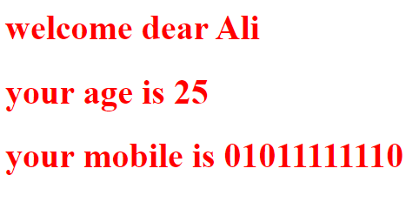

Try these extra bonus:
- Create a function that takes three integer arguments (a, b, c) and returns the amount of integers which are of equal value.Your function must return 0, 2 or 3. Examples:
equalFunc(3, 4, 3) ➞ 2
equalFunc(1, 1, 1) ➞ 3
equalFunc(3, 4, 1) ➞ 0

- Write a script that takes from the user some values and check that the entered data is numeric , stop receiving values from user when he enters 0 or sum exceeds 50, then inform the user with the total sum of the entered values with alert.
- Ask the user to enter a message then display it using the different HTML heading tags (from <h1> to <h6>) using Loops. DO NOT write the header tags explicitly in your HTML!
